
Koneru Lakshmaiah Education Foundation
(Deemed to be University estd. u/s. 3 of the UGC Act, 1956)
Off-Campus: Bachupally-Gandimaisamma Road, Bowrampet, Hyderabad, Telangana - 500 043. Phone No: 7815926816, www.klh.edu.in

STUDENT CASE STUDY EXECUTION REPORT
Department | FED
Subject | DSA-2
Academic Year | 1-111 Semester | 2025-26
Faculty Name | Mohd. Razia Alangir Banu
Student Name | P. Yaswanth Surya
Roll Number | 2520030581
Branch | CSE
Course Outcome | CO 3
Case Study Topic: Content Delivery Network Optimization using BFS, DFS, Kruskal's and Prim's Algorithms
Work Done Summary:
In this case study, we implemented graph traversal and Minimum Spanning Tree algorithms to optimize MediaVault's Content Delivery Network (CDN). Streaming servers were represented as graph vertices and network links as weighted edges. BFS and DFS were used for connectivity analysis, while Kruskal's and Prim's algorithms minimized network deployment costs.

Implementation Details:
1 Represented CDN servers using graph data structures.
2 Implemented BFS traversal for network exploration.
3 Implemented DFS traversal for connectivity analysis.
4 Constructed Minimum Spanning Tree using Kruskal's Algorithm.
5 Constructed Minimum Spanning Tree using Prim's Algorithm.
6 Compared network costs before and after optimization. 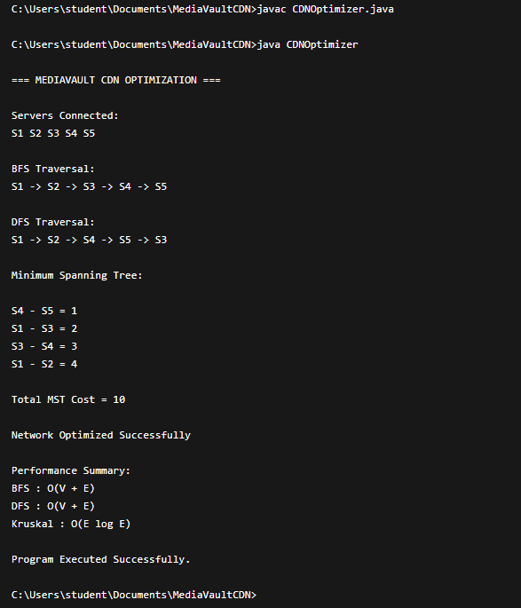

Result: Screenshots / Output
The graph algorithms successfully identified connected servers and minimized infrastructure costs.
Sample Output:
- BFS Traversal: S1 → S2 → S3 → S4 → S5
- DFS Traversal: S1 → S2 → S4 → S5 → S3
- MST Edge: S4-S5 Cost = 1
- MST Edge: S1-S3 Cost = 2
- MST Edge: S3-S4 Cost = 3
- MST Edge: S1-S2 Cost = 4
- Total MST Cost = 10

Time Complexity:

- BFS: O(V + E)
- DFS: O(V + E)
- Kruskal's Algorithm: O(E log E)
- Prim's Algorithm: O(E log V)

The optimized network reduced infrastructure costs while maintaining complete server connectivity.
.

GitHub Link: https://github.com/yaswanthsurya-99/DSA-2
Student Signature Faculty Signature

